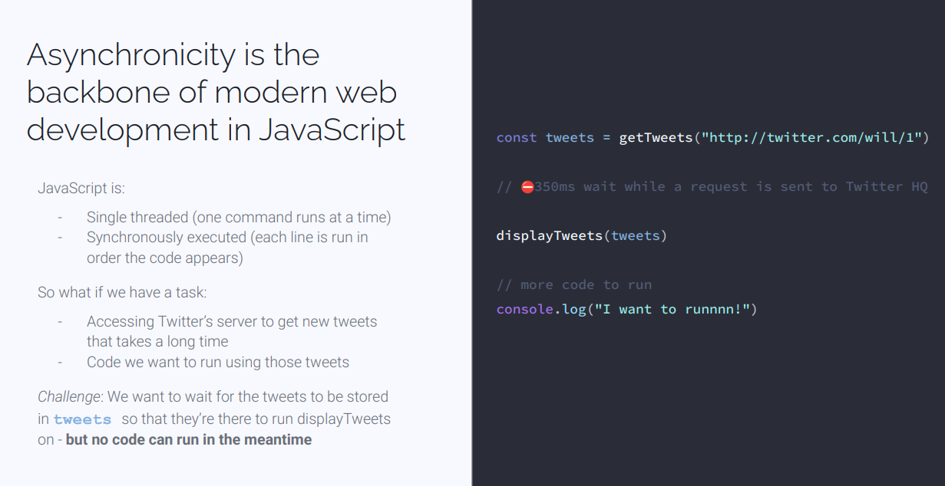
Async getTweets(https)
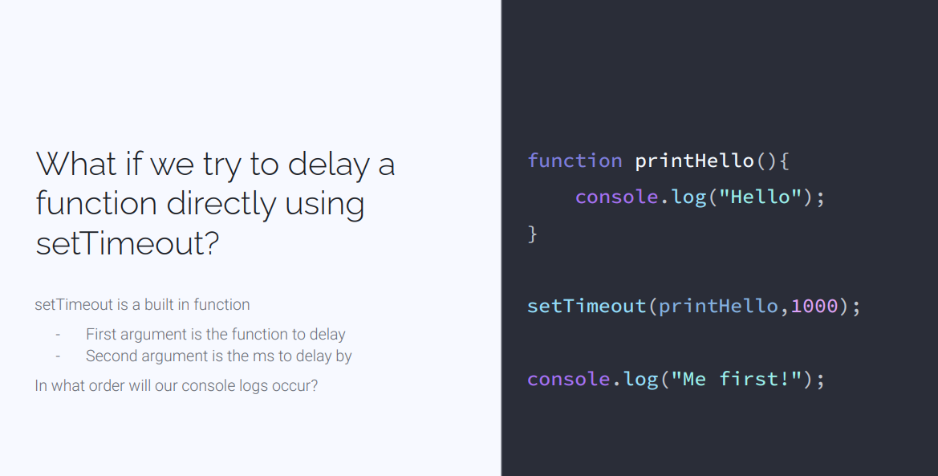
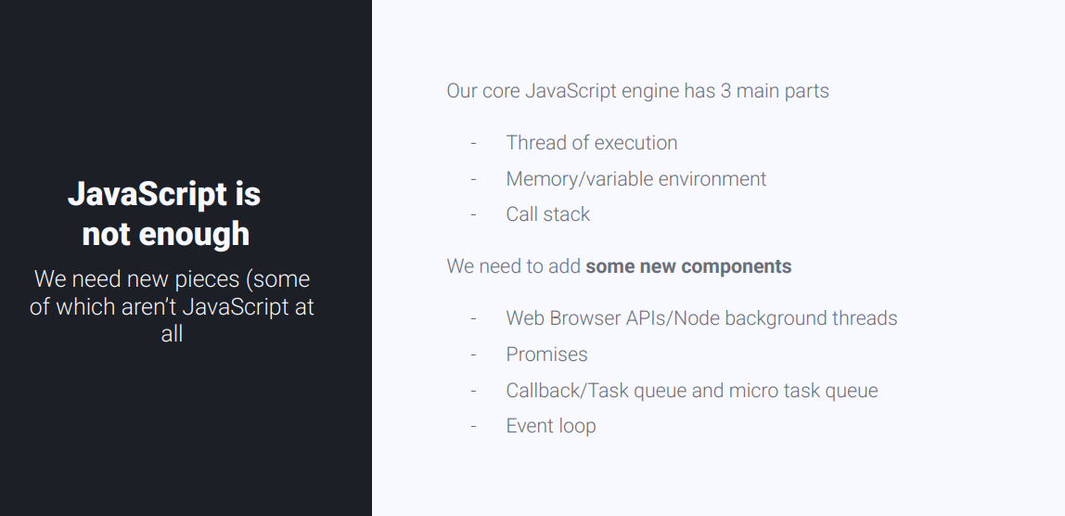
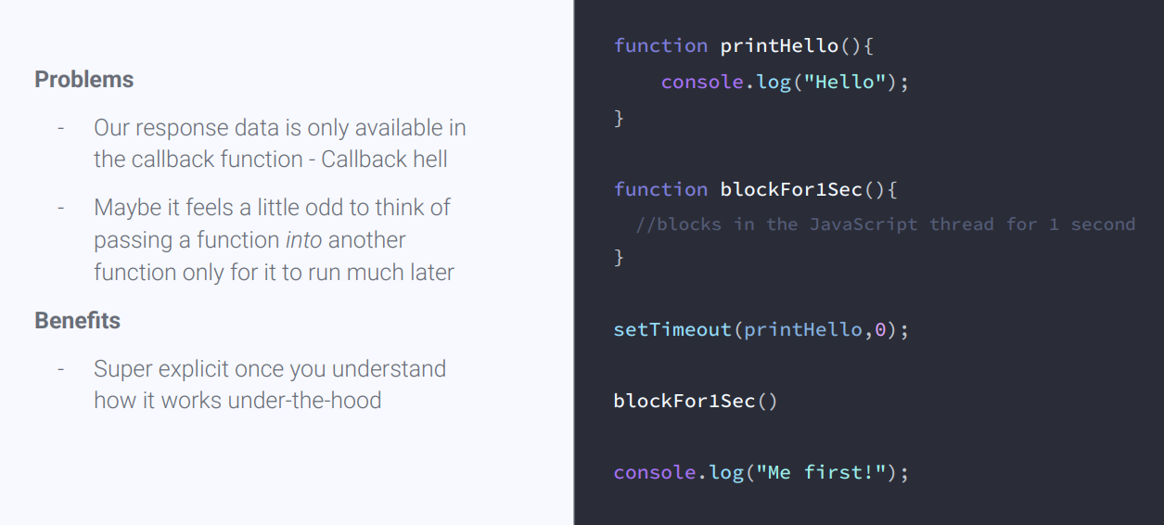
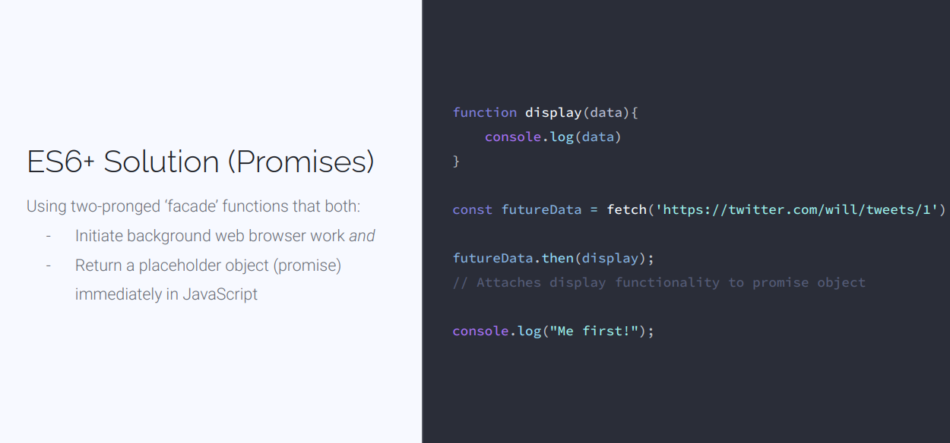
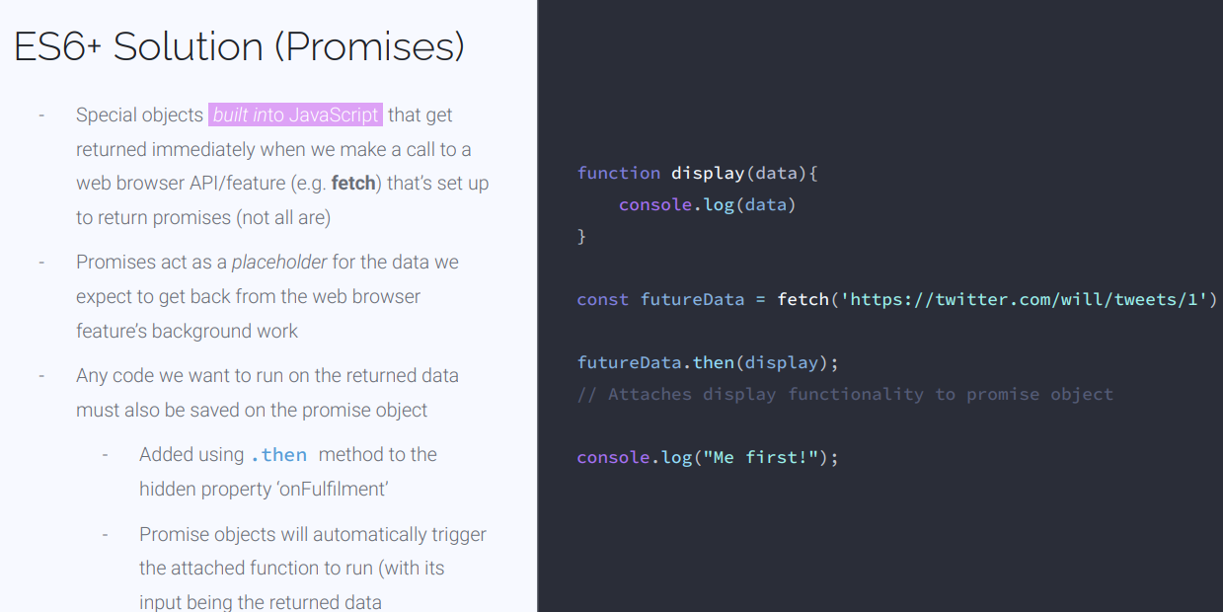
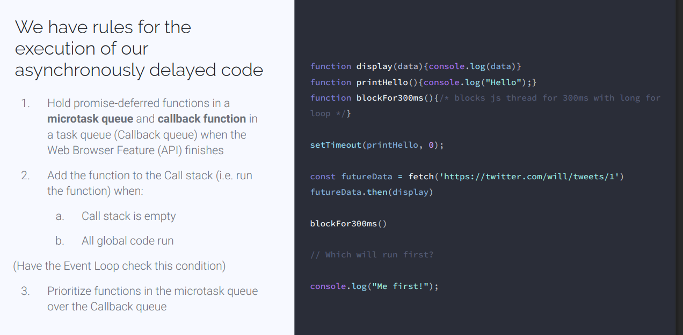
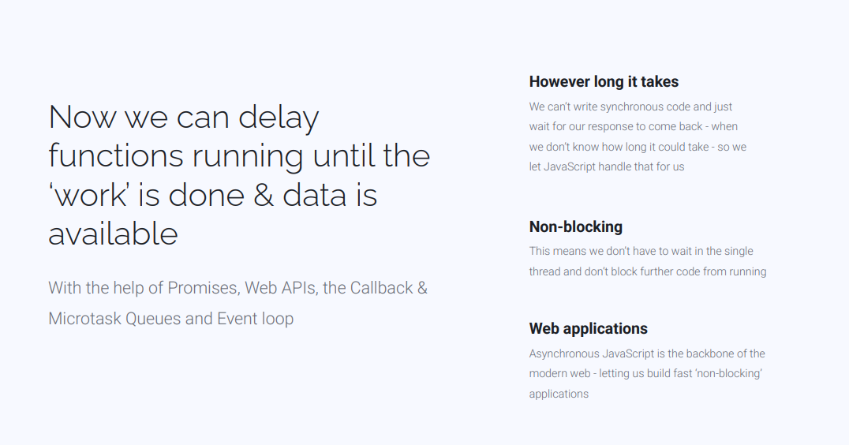

Asynchronous
Synchronous = in sync line by line (single threaded)in JavaScript
SetTimeout (1000) is one solution – manually Stop code by one second or 1000 milliseconds
Promises special objects built into Javascript that can return immediately when we make a call to a browser API or feature such as a fetch that’s set up to return a promise
That then keyword will until whatever function is the callback completes before calling it ssexample
Function display(data){console.log()}
futureData = fetch(“https”)
futureData.then(display);
Promise objects {value:
And
Unfullfilled:[]
onRejected:[] // for errors handling function}
Promise.value= futuredata.value = whatever we got back on the request
.then() = will return when the background work is done, placed in the microtask que then callstack
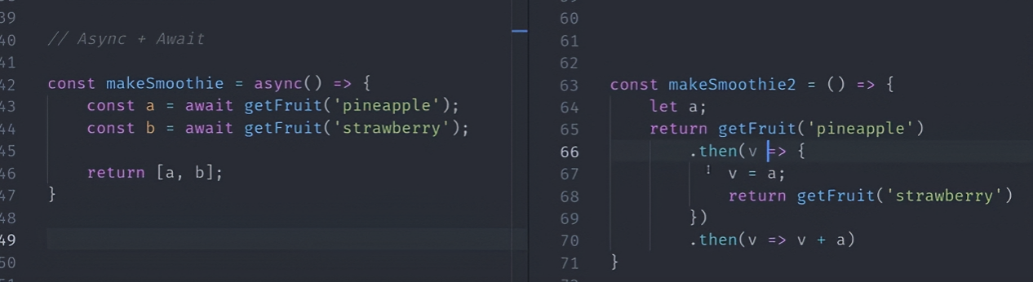

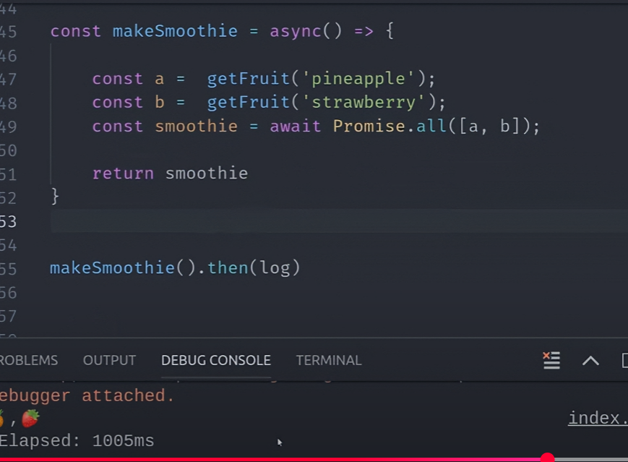
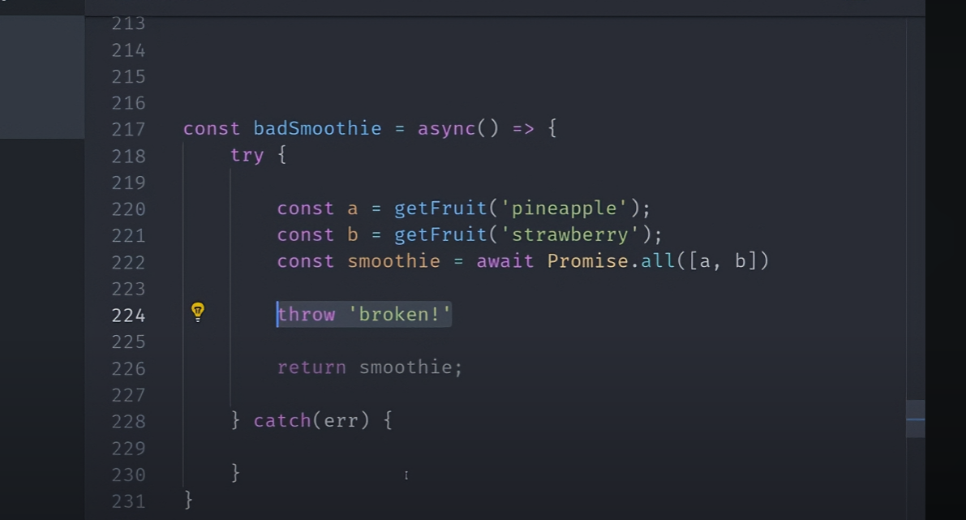
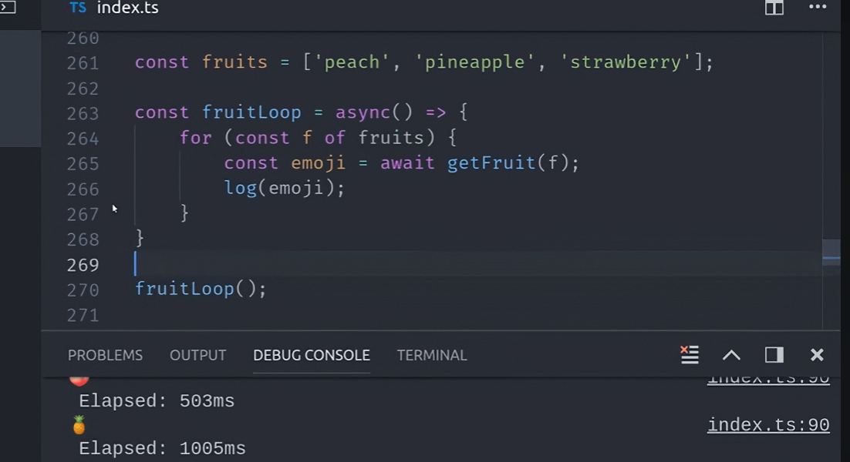

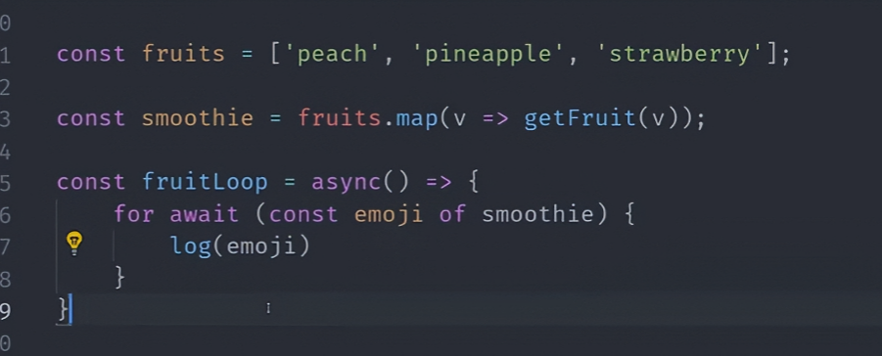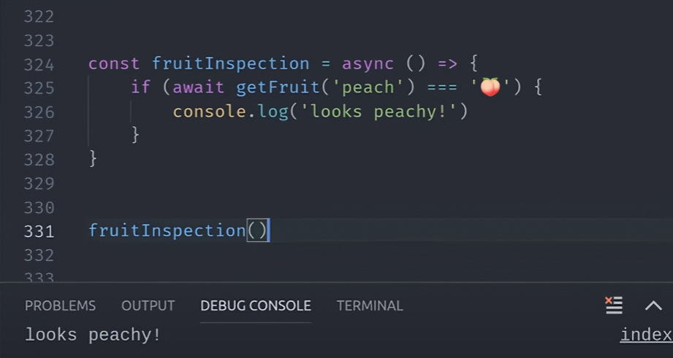
Event Loop
JS is a single threaded language – 1 thread to run all our code
setTimeout – runs our code in parallel
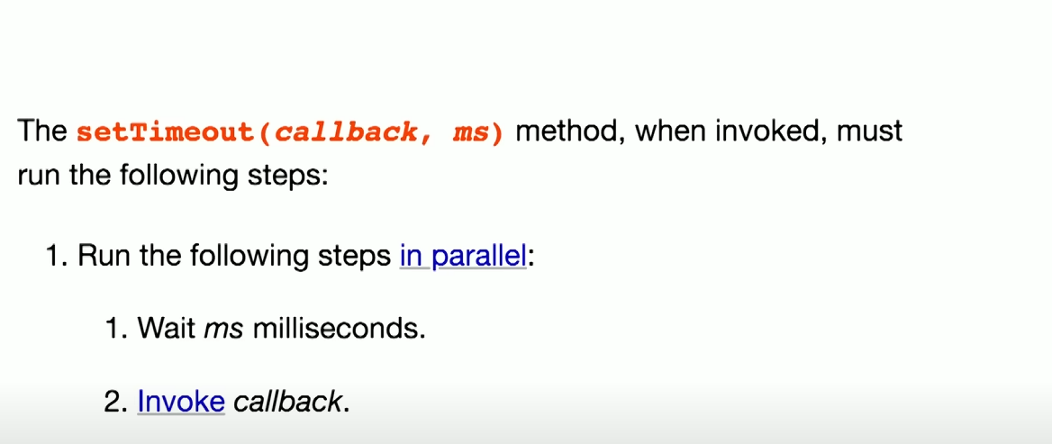
In actuality this is what it does
- Wait ms milliseconds
- Queue a task in the microtask queue
- Invoke a call back
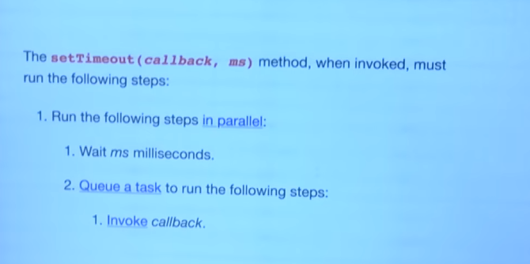
Event Loop
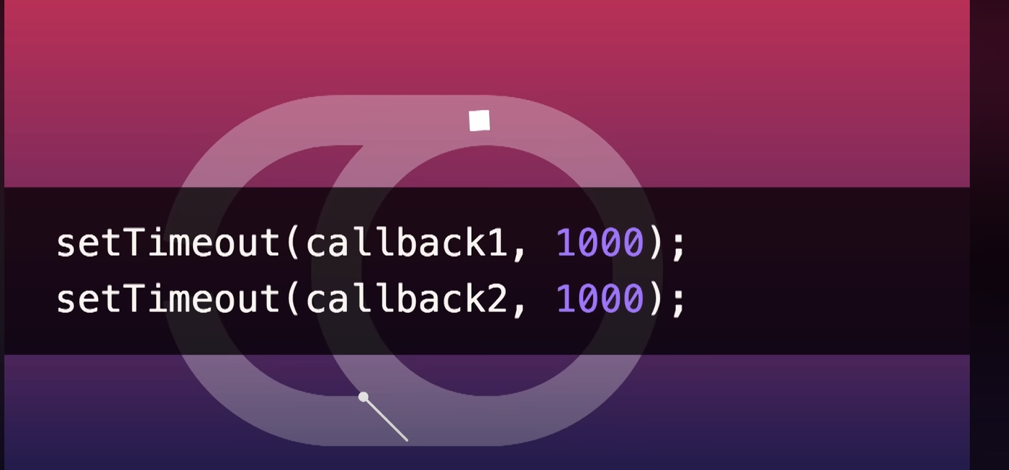
2x setTimeout runs in parallel
1 clalback runs in the even loop
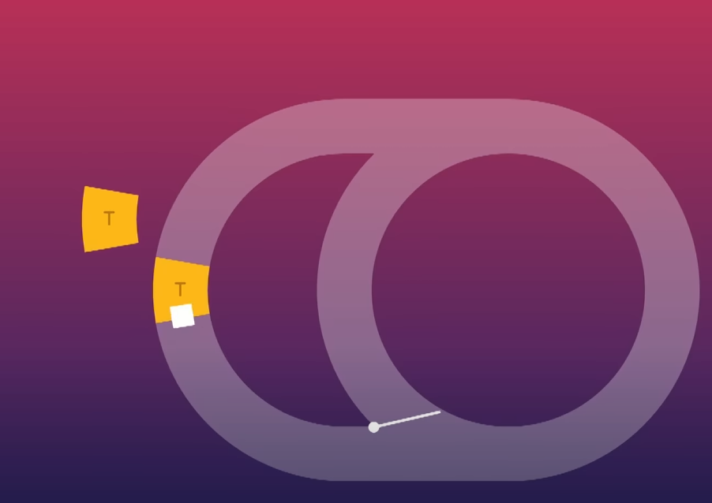
Then second callback
Same as first
Scenario while loop infinite loop = blocks rendering in the DOM
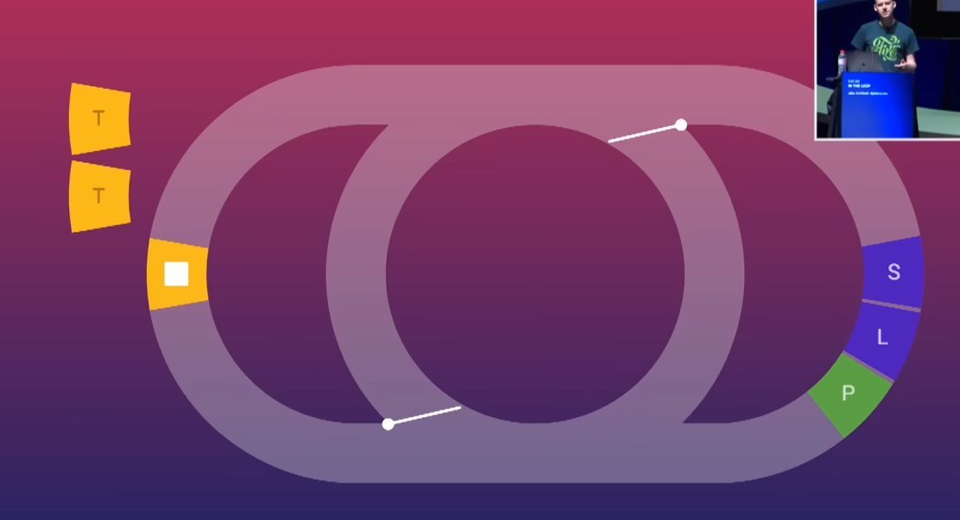
EVEN LOOP
1 queue a task
2. even loop picks up a task
3. repeat
4. render when it needs to (using button clicks or manipulating the dom)
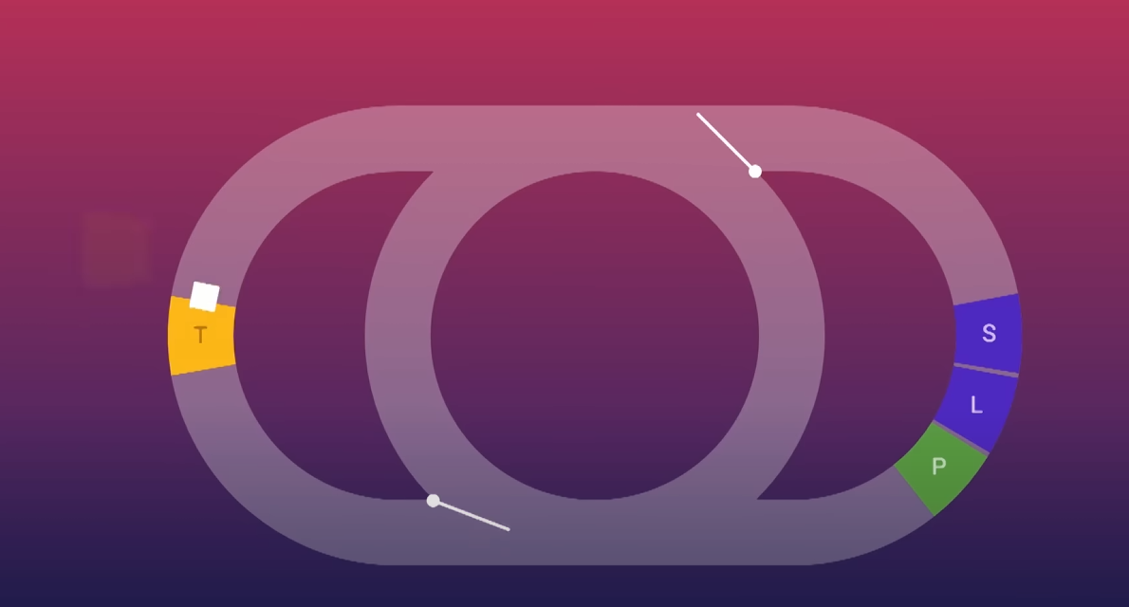
Event Loop - Microstask
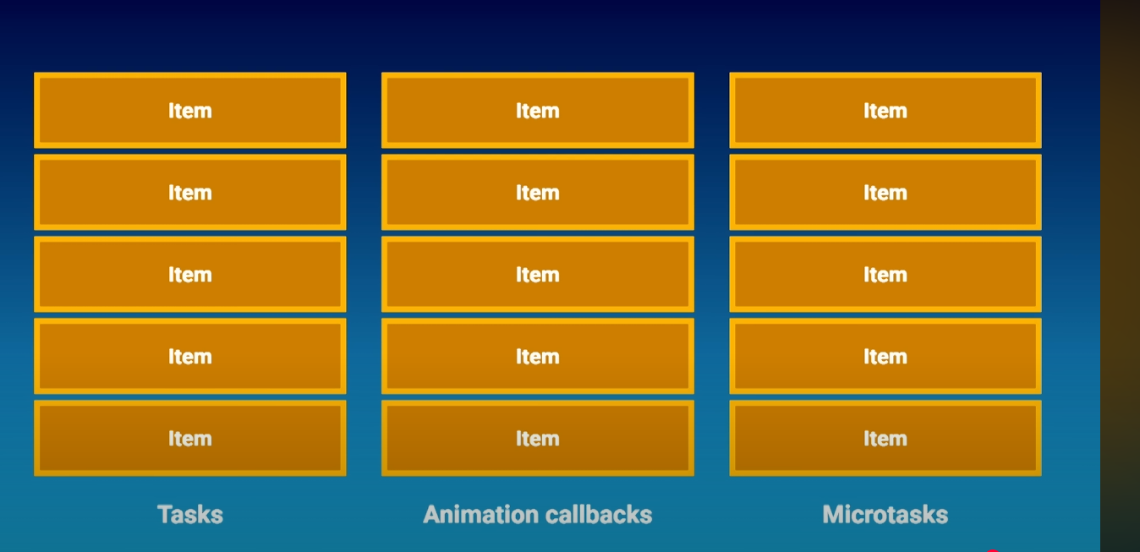
Tasks – in the callstack = LIFO
Microstask queue – in the queue = FIFO (processed to completion including any additional queue items) – blocks rendering
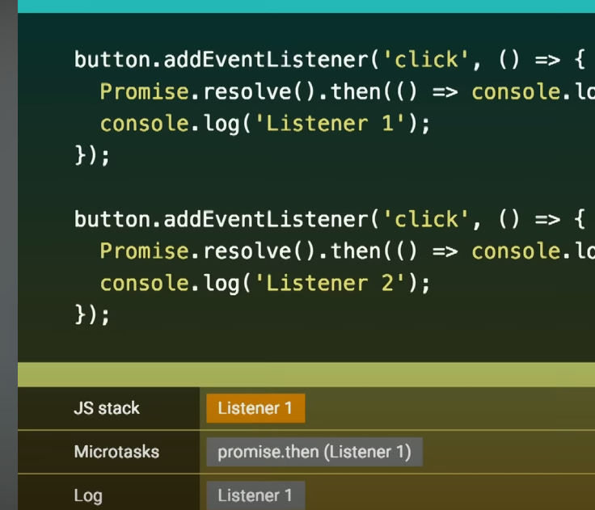
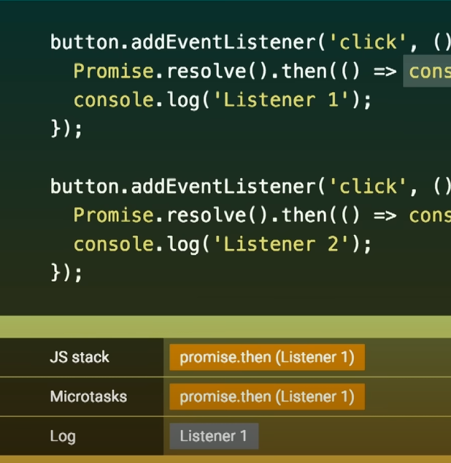
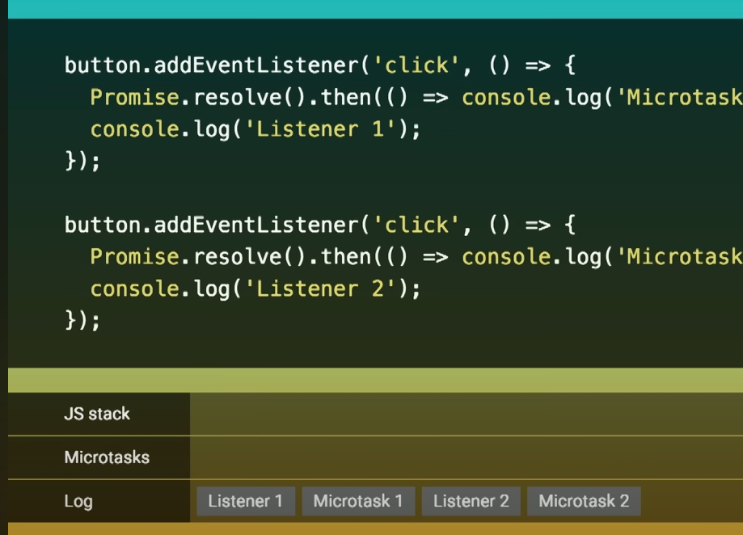

Callstack code
the code does not run inside the callback queue. The callback queue is just a waiting area so when the call stack is empty, the even loop takes the next task from the callback queue and pushes it onto the call stack

Async code execution
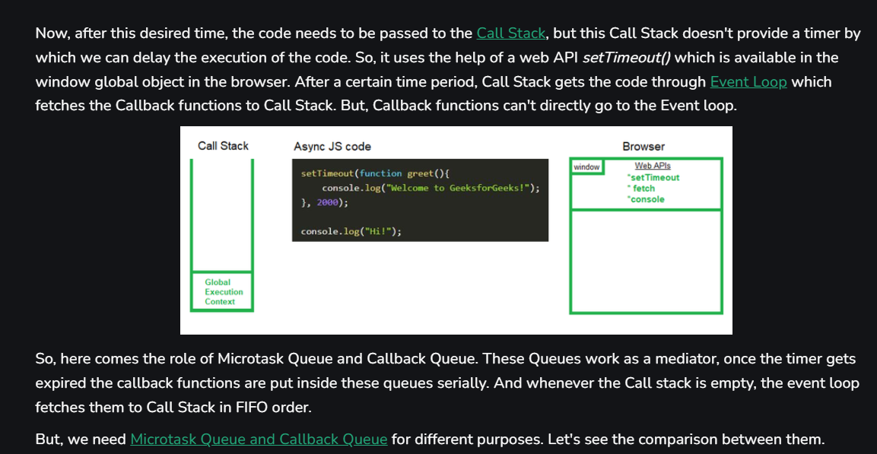
Callback Queue
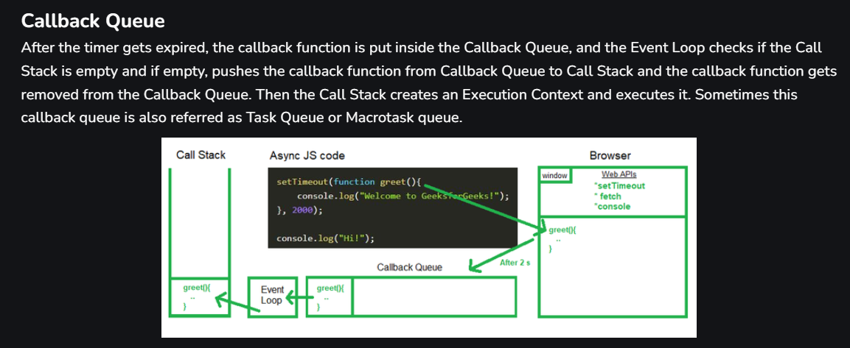
Microstask Queue
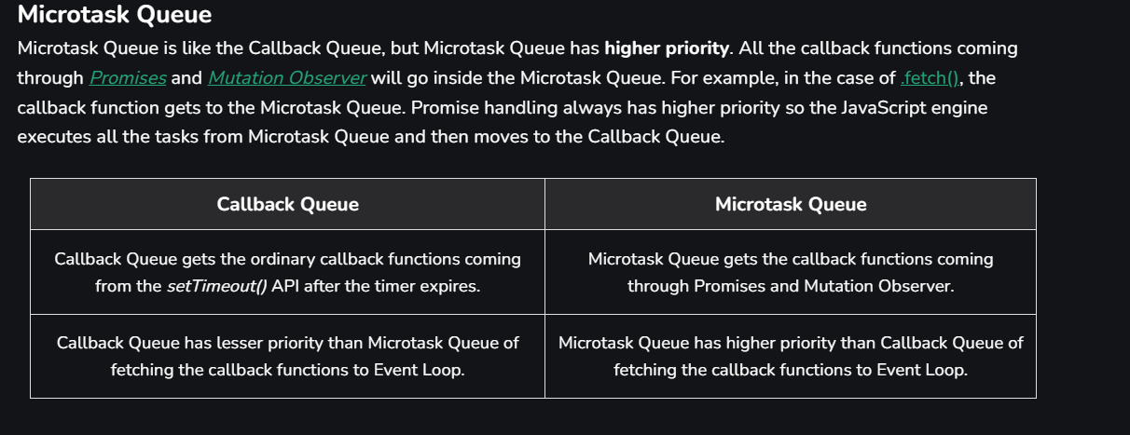
Event LOOP
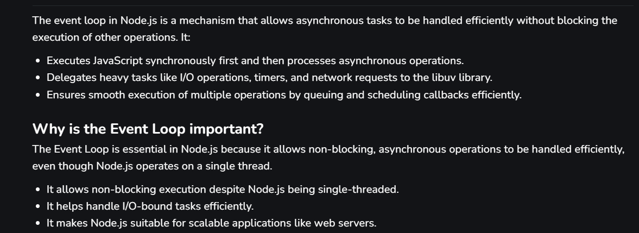

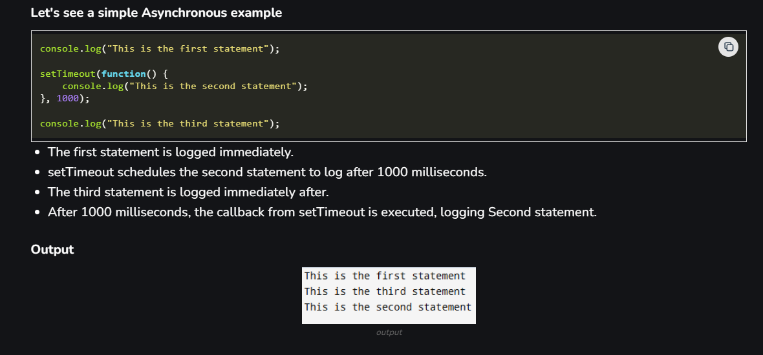
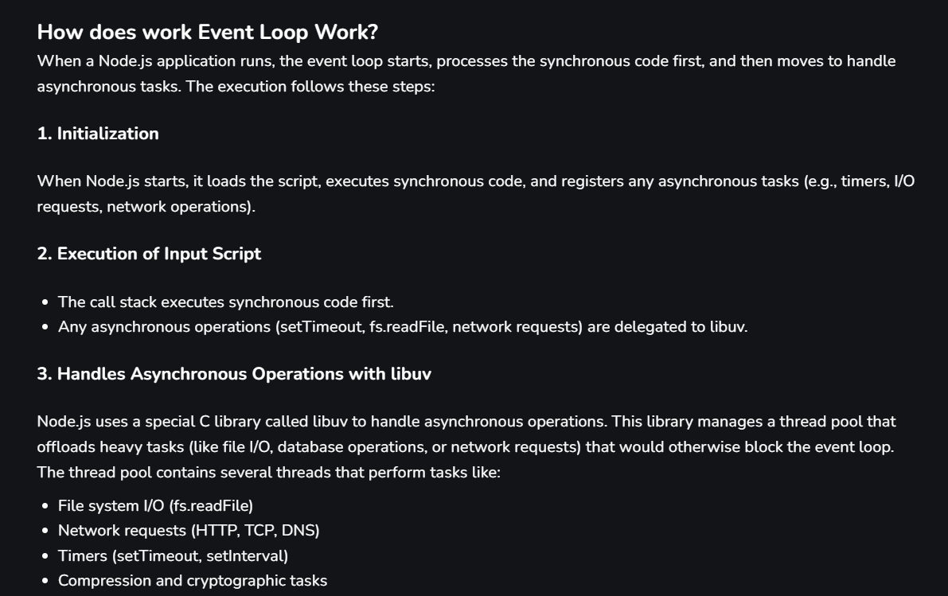
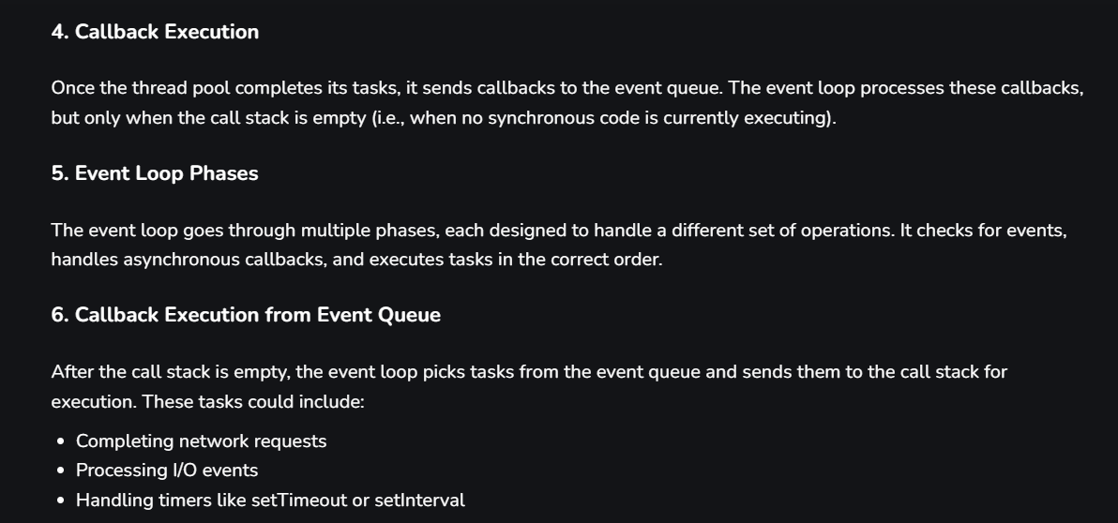
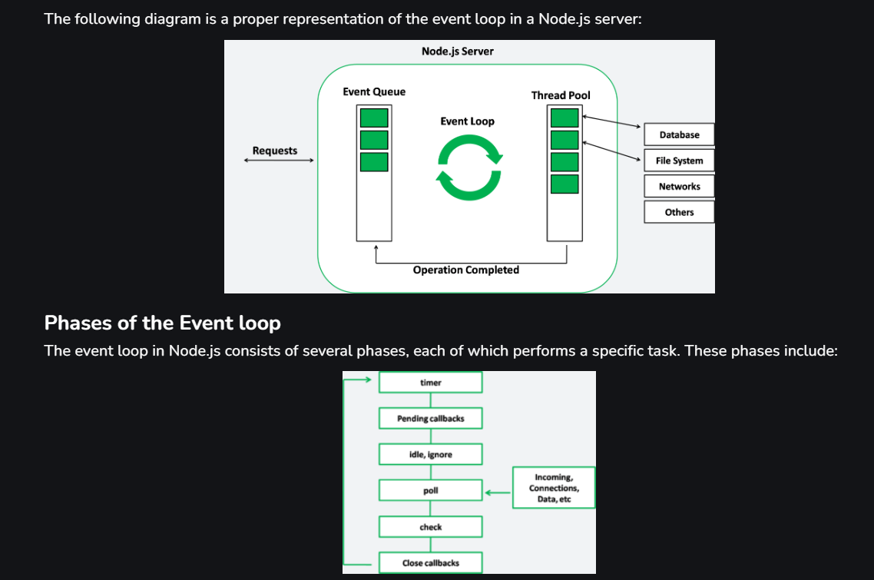

Promises

